Project #1: Boot-testing machine

ME3310

Edgar Buenrostro

Joseph Gallagher

Maria Isabel Paredes

**Abstract:**

The objective of this project was to design a fixed linkage mechanism to load-test army boots. The U.S. Army needs to effectively and quickly determine if new boot designs can withstand the repeated stresses that they will encounter in use, as well as environmental effects. In order to perform these tests, the boots must be moved across a load plate through a cycle that realistically represents a soldier’s walking motion, including both positional and angular requirements. The final solution drives the boot using a combined Grashof Four bar crank rocker and crank-slider, arraigned as a modified Stevenson’s type III six bar linkage. The device precisely replicates the angular position of a boot throughout the walking cycle, within 3 degrees, and keeps the boot in contact with the load plate during the entire test. The boot is reset to its starting position using a quick return mechanism, which allows 64% of the mechanism’s cycle to be spent actively testing the boot. The final linkage system is compactly packaged, comfortably fitting within a 24” space.

**Table of Contents:**

1. Introduction……………………………………………………………………..3
2. Background Research ......................................................................................... 4
3. Goal Statement ................................................................................................... 9
4. Task Specifications ............................................................................................ 9
5. Design Description............................................................................................. 10
6. Results ................................................................................................................25
7. Conclusions........................................................................................................ 29
8. Bibliography ..................................................................................................... 29
9. Appendices ....................................................................................................... 31
10. Model ........................................................................................ inside back cover

**1: Introduction**

This report describes the design and analysis of a six bar linkage mechanism, which simulates the movement of a foot while walking. The problem solved during the project was provided the U.S Army, who needed a boot testing machine. Boots need to be tested for durability and environmental resistance, before they are manufactured on a large scale. As part of this objective, the U.S Army requested our school, WPI, to create a machine which would walk a boot against a load plate, in a motion similar to that created by a marching soldier. This relatively complex motion must be created using a linkage mechanism, driven by a continuously rotating motor.

The following report outlines our team’s efforts, as we researched and better defined this problem, and generated solutions. First-order feasibility analysis is included, in addition to detailed accounts of the iterative design process incorporated by the team.

**2: Background Research**

The first step in our design process was to develop a better understanding of the “walking motion” that was requested, and to research existing mechanisms that perform similar jobs. Our research was divided into three basic areas: Walking motion, Walking linkages, and Shoe testing devices.

**2.1: Walking Motion**

Before looking for any information regarding walking linkage devices, we sought videos on the web which simulated the specific walking that we needed. At first, we searched without success for a detailed profile video of soldiers marching. However, after discussing the problem with members of ROTC (Reserve Officers' Training Corps), we learned that a soldiers marching motion and what is considered “normal walking” is effectively the same.

Following this discovery, we located multiple videos of the human walking motion(16). It became clear that the foot always follows a 3 position cycle of heel down, flat, and toe down. However, most videos available online were too quick to accurately quantify the angles that the foot makes.

To remedy this problem, we developed a testing setup. A digital video camera was mounted to a miniature tri-pod near ground level, pointed at a wall with a horizontal reference line. Volunteers walked past this camera repeatedly, planting their feet directly in the camera’s view. *Figure 2.1* illustrates a typical still capture from these tests.

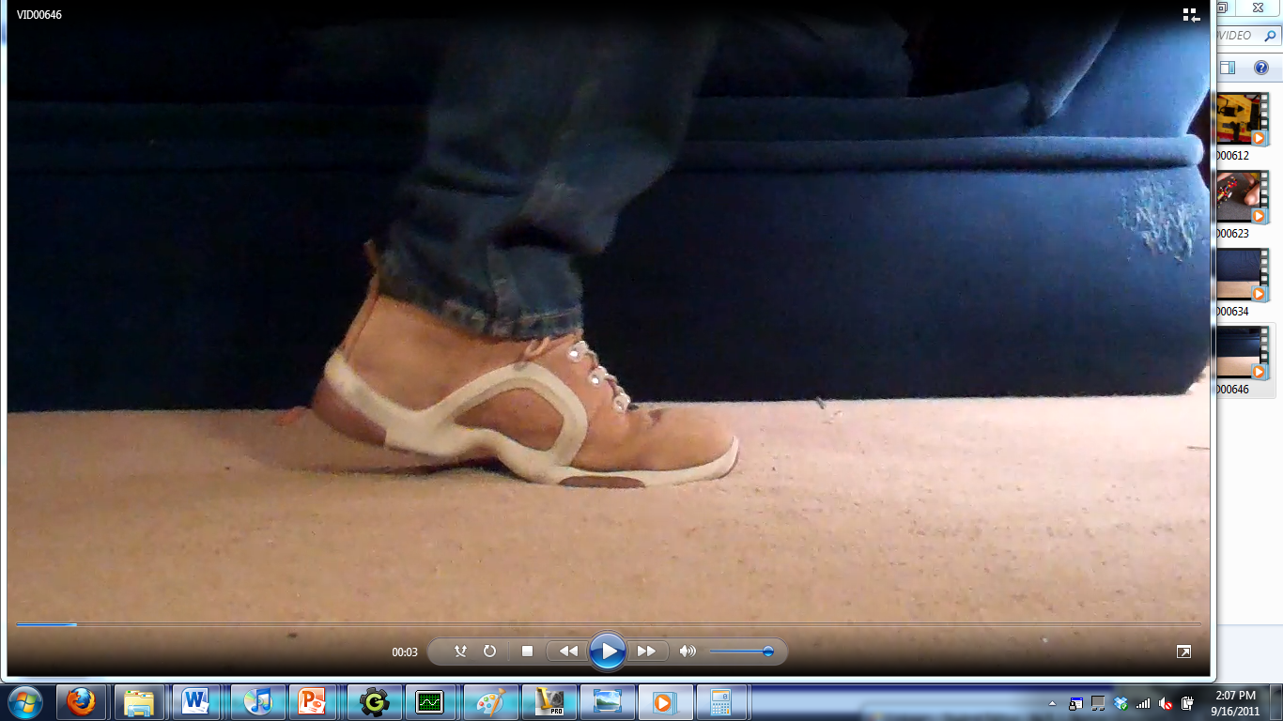

*Figure 2.1: A still capture from one of the walking analysis videos se created. The sole’s angle relative to the carpet/background transition was used to quantify the shoe’s motion.*

These videos were then slowed down to 1/8th speed using video editing software. The frames during which initial and final contact with the ground were isolated. The relative angle between the shoe’s sole, and the horizontal reference in the background was used to determine the angle that the shoe strikes and leaves the ground. Data points from a series of trials were averaged together, giving us a typical initial contact of 22̊, heel first, and an average final contact of 41̊, toe first. The raw data from these tests is included in the appendix.

**2.2: Walking Linkages**

Once we understood the shoe’s motion, we began to research pre-existing linkage mechanisms designed to reproduce this motion. The first mechanism investigated was the Klann Linkage. The Klann Linkage (Figure 2.2) is a planar mechanism design to simulate the gait of legged animal and function as a wheel replacement. It is a six-bar linkage that consists of the frame, a crank, two rockers, a connecting arm or rod, and a reciprocating leg that are all connected by pivot joints.

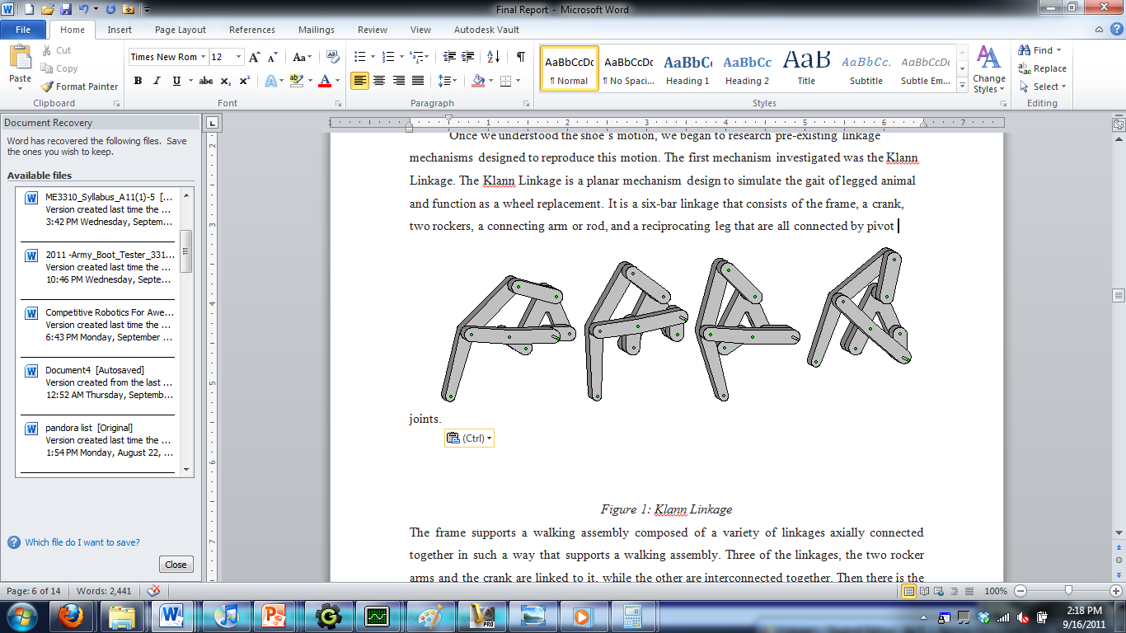

*Figure 2.2: The Klann Linkage*

The frame supports a walking assembly composed of a variety of linkages axially connected together in such a way that supports a walking assembly. Three of the linkages, the two rocker arms and the crank are linked to it, while the other are interconnected together. Then there is the cranking link that includes a crank shaft powered by a proper power source, and a crank pin. This shaft powered by the power supplier, creates a rotational motion to the crank pin which then transfers its motion to the rod. Each revolution will create one complete step. This rod is also connected to one of the rocker arms that rotate about the crank link causing it to move upward and downward through an arc path of 180 degrees. Any movement past this degree will be considered a backward motion until the 360th degree is reached; degree where it is considered to have reached a complete cycle. Both of these rocker arms connected to the frame have the advantage that limit the translational motion of the respective leg.

The other complex walking mechanism we researched was the Theo-Jansen mechanism (figure 2.3). Compared to the Klann Mechanism in which it had its own origin, the Theo-Jansen Mechanism is a mechanism derived from the Klann mechanism itself. This is an eight bar linkage designed by Dutch artist and mechanical engineer Theo Jansen.

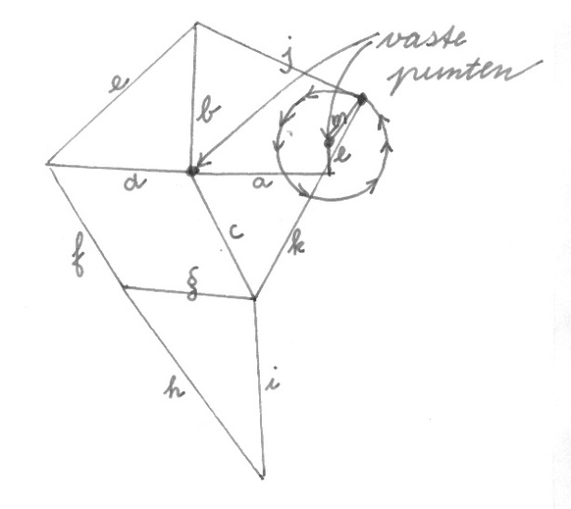*Figure 2.3: Theo-Jansen Mechanism*

It consists of two pivot points with a common axis (link a): one that connects the cranking linkage, and the other one that connects with the other links. The crank located in joint e, connects with two coupler links (links k and j)that accordingly move the upper and lower triangles of the mechanism (Triangle AEL and triangle GHI) Both of these triangles are then connected by two separate links (links f and c), one which is a coupler and the other one the rocker. As in the Klann Mechanism, this rocker link (link c) limits the angular movement of the lower leg, giving it a specific coupler curve. Eventually, with the use of any power source implemented in the crank, the mechanism will be able to simulate the action of walking.

In addition to these complex linkages, we also researched simpler walking systems. Mechanisms based on inverted crank-sliders provide a bumpy yet effective gait, and have been used in many mobile robots. This mechanism’s key advantage is its simplicity.

But as effective as these linkage designs are at propelling devices that walk, they have a severe limitation when it comes to the problem of boot testing. They are designed to propel a device forwards, and have significant horizontal travel. While we want our boot to take on the angular and vertical position of a walking foot, we want it to remain stationary in the X direction, relative to the load plate. At this point, we shifted the focus of our research from walking linkages to shoe testing systems.

**2.3: Shoe Testers**

One of these machines researched was an engineering medical device of a 3-axis machine used to characterize the performance of running shoes(9). This machine made by graduate students from Massachusetts Institute of Technology, had a functional requirement of simulating and measuring the foot kinematics and dynamics during running. It would include multiple phantom feet that would be mounted on a rotary motor at a constant speed. With this device, there would be included a moving base that would impose the appropriate kinematics on the shoe. Also the shoe and the base would have sensor in order to record the dynamic information about the forces and displacements acting on different parts of the phantom foot. Moreover, even though this kind of device is not an actual four-bar linkage, it still simulates the movement of the foot, and records the force applied while walking.

 Another type of shoe tester that we investigated was a shoe measuring apparatus called the Mini Bionix II system. Instead of simulating the movement of the foot, it only measures loads applied to the foot by running fatigue cycles on biomaterials at frequencies up to 30 Hz. The shoe is applied into the apparatus after which the load compresses the shoe’s heel.

*Figure 2.4: Mini Bionix II system*

Also, by adding a transducer, this standard machine can accurately run soft-tissue tensile and fatigue tests in the milli-Newton range. Also it contains an axial/torsional system, which adds the capability of controlling torsional moments of the shoe, while providing a multi-turn rotational control for continuous rotation. Similarly to the MIT thesis, it also measures the force applied to the shoe; however, this machine won’t simulate the rotation of the leg. In addition, another counter back about this machine is that it only test loads on the heel, rather than across the entire sole.

Including into the list of shoe testers that we researched, we found a mechanical device that also simulates the foot’s motion. This includes a rotational device (figure 2.5), with several spring loaded spokes, each one with its own attachment point. As the wheel rotates, each shoe is able to “walk” into a small treadmill, which eventually simulates the motion of walking. This mechanism demonstrates the quick and dirty approach of using springs to retroactively angle the shoes to the correct orientation.

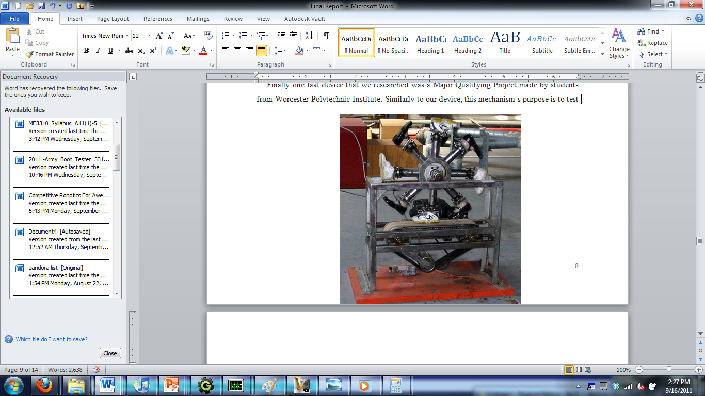

*Figure 2.5 Rotational Shoe-Testers*

Finally, one last device that we researched was a Major Qualifying Project made by students from Worcester Polytechnic Institute. Similarly to our device, this mechanism’s purpose is to test the durability of an army boot by simulating the human walking motion. Its linkages simulate a coupler curve which the boot follows; hence, simulating the real walking motion. The linkage is driven by a dyad which is connected to a motor that powers the linkage system. As the boot runs through the cycle, it steps into a plate where there are two force transducers, on in the front and one in the back of the plate. The purpose of the force transducers is to measure the force done on the boot as it strikes the plate itself. This device was relatively effective. However, it reversed its direction of travel, effectively walking backwards. To prevent unrealistic loads from being placed on the boot during this phase, a second actuator was used to remove the load plate.

**3: Goal Statement:**

Design a stationary system that simulates the motion of a marching soldier’s boots.

**4: Task Specifications:**

1. Accommodate a boot 12 in in length, plus or minus 1.5 inches
2. Must have only one degree of freedom.
3. All joints must be full joints.
4. The input link must complete a full revolution, continuously driven by a motor at a constant velocity.
5. All transmission angles should be greater than 35 degrees.
6. The input link must be grounded.
7. At least 50% of the mechanism cycle time should be spent actively testing the boot rather than moving the book back to the stop position.
8. The mechanism must be a linkage device with no more than 8 links.
9. Boot will not slide on the ground as it is tested.
10. Mechanism will largely control the boots vertical position throughout the test using rigid links. No more than ¾ ‘’ of travel may be made using flexible links.
11. The boot should make its first contact with the ground heel first, at a 22 angle, +/- 3.
12. The boot should rotate down to a level position, with the sole of the boot flat on the ground.
13. As the boot pivots forward to the toe-first position, the boots motion should force the toe of the boot to bend upwards. This bend should occur at a point approximately ¼th of the boots length from the toe end.
14. The boot should make its last contact with the ground toe first, at a 41 angle, +/- 3.
15. This return motion should largely occur in the air, without the shoe contacting the load plate, insignificant contact at the toe or heel, occurring at the beginning or end of the return motion respectively, are acceptable.
16. This return motion should take as direct a path as possible, to avoid unneeded accelerations on the boot.
17. The mechanism must be able to withstand a 1000 pound load applied on the boot, with a safety factor of 1.5.
18. The mechanism, not including motor, must fit within a 4’ cube.

**Design Description**

**5.1 Initial Concepts from Research**

Our first round of concepts was based heavily on many of the walking linkages described in section 2. At this point, we knew that we wanted our linkage to simulate the rotating leg angle found in devices like the Theo-Jansen linkage, but remain relatively stationary in the horizontal direction. These early attempts at removing the horizontal motion from walking linkages were largely unsuccessful; either not removing enough X motion, or adversely affecting the desired rotation of the foot. Additionally, the complexity of these linkages, designed to create optimal walking gait, was unnecessary and undesired in the simpler stationary test application.

Following these attempts, the group engaged in brainstorming, and developed a wide variety of concepts. The objective of the exercise was to come up with a diverse set of linkage concepts, to be analyzed for practicality later. Some of these were based of simpler walking linkages with cruder motion, like the inverted crank rocker system. Others were derived from other linkage mechanisms, such as the film-advance linkage, and various straight-line linkages. Concepts were expanded upon using inversion, and by re-orienting previous concepts relative to the load plate. The exercise was a success, producing a wide variety of relatively simplistic designs that would later prove very useful.

However, when we began to optimize and analyze our concept sketches, we encountered a problem. While there was little difficulty involved in modeling most of the concepts using LINKAGES and Solidworks, it was difficult for us to judge if tests performed using this software was a “success.” Most concept sketches featured the boot connected to a coupler link in a relatively arbitrary location. When the linkages were modeled, it became apparent that the location of the boot relative to the coupler link made a huge difference in its motion, just as the coupler curve is different at each point. Even more problematic was our inability to intuit how to improve the system, when the boot’s motion did not come close to our task specifications. We realized that we needed a better way to describe the correct motion of the boot, so that we could better quantify what our concepts were doing right and wrong. This led us to revisit our walking motion analysis, and to plot the motion of individual points on the boot. Then, we could design our linkages to follow a coupler curve that closely matched that followed by the boot.

**5.2 Analysis of Boot Motion**

Data generated during background research was used to plot the curves created by various points on (and near) the boot. The average angles of contact and release: 22̊ heel down and 41̊ toe down respectively, were used to create a 1:2 scale, animated boot. This boot was rotated through the walking cycle in a realistic fashion. As the boot rotated from heel down to flat, it spun around a point near the back of the boot’s sole. Once the boot reached this flat position, it continued to rotate; this time around a point located approximately where the boot bends, as it pivots toe-up. This creates the toe bend required by task specification #_. This rotation continued until the boot reached 41̊. A six frame animation was created, giving enough accuracy to infer the true shape of the coupler curve

As shown in *Figure 5.1*, a grid was superimposed over the boot. The points on the grid moved with the boot, just as they would move in real life. To determine the curve formed by a specific point, the six X and Y coordinates of that point could be recorded, as the point translates across the six frames. These six coordinates were then plotted and connected, giving a good representation of the point’s travel. 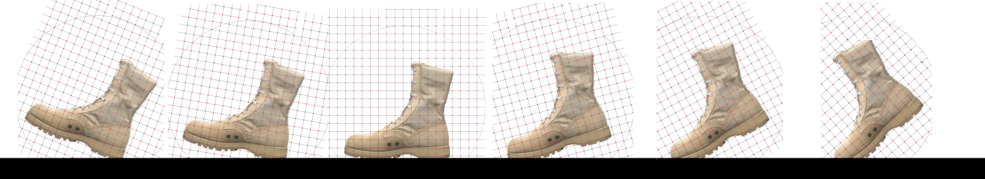

*Figure 5.1: Boot animation and grid used to plot curves*

As a result of the variable rotation point of the boot, the curve formed generally resembled a double arc. As the boot moved from heel down to flat, the point would move in a circular path, about the stationary point on the heel. At the flat frame, the center of rotation would shift to the toe end of the boot. This created two arcs, joined together at a sharp, cusp-like point where the center of rotation shifted. This double arc would be used as the active part of the coupler curve; the one that actually performs testing. For the return, the point could take any path, as long as it remained above the active portion of the curve.

Once we understood the relatively simple geometry of our coupler curve, it was modeled using easier to work with mediums, including sketches and CAD. *Figure 5.2* shows 7 characteristic double-arcs, plotted using a compass. It also illustrates some of the patterns that result from moving the point of interest around, relative to the boot. Near the sole of the boot, the arcs are nearly tangent to each other, and form a very sharp cusp. The total distance covered by the point is quite small. As the point of interest moves upward, the curve flattens out, with the transition from arc 1 to arc 2 becoming more gradual, approaching (but never reaching) a single arc. The distance travelled by the point also increases dramatically, since the radius of rotation grows, and the point must travel further to cover the same angular change. Left/right shifts tend to angle the curve, and cause one arc to flatten out while increasing the curvature of the other.

**5.3 Initial Coupler Curve Searches**

Once the paths of various points on the boot were plotted, the next logical task was to find linkage coupler curves with a close match. This task proved challenging. Our ideal coupler curve was a very sharp, very clean geometric shape, unlike the complex, curve-dominated paths of most coupler curves. Initial searches through the Hrones and Nelson Atlas were unsuccessful. Geared five bar curves were not thoroughly researched, as they tended to provide even more complex curves than a four bar linkage, while adding complexity to our system. Most linkages developed during our initial brainstorming didn’t show much potential for matching the boot’s curve either.

However, several promising curves were found in Design of Machinery, in the table of symmetric linkage curves. A banana shaped coupler curve with a small “bump” on the lower arc was seen on several of these, most notably the link with a common link ratio and ground link ratio of 2.0, and a coupler angle of 144 degrees. This linkage was modeled in LINKAGES software. We spent some time experimenting with small tweaks to the linkages geometry, to intensify the presence of the bump in the curve, and to make the symmetrical linkage asymmetric, to better match our ideal coupler curve. This was generally done by changing the geometry to closer resemble symmetrical linkages which created a cusp. Several variants were developed, most with coupler curves resembling *Figure 5.3*.

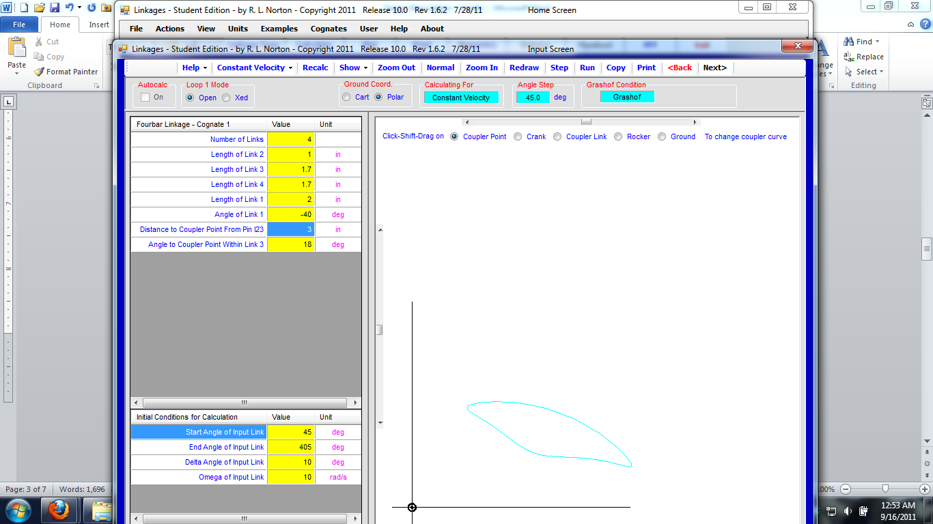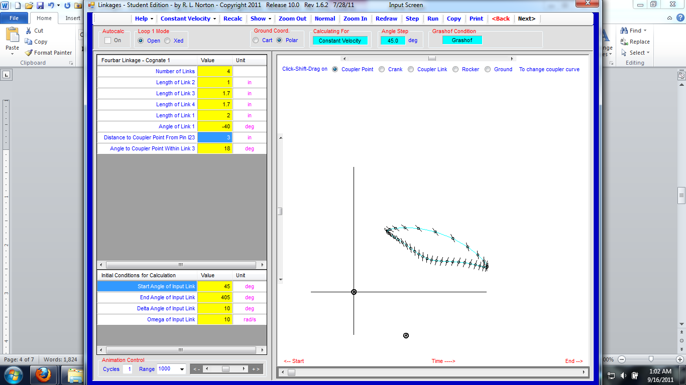

*Figure 5.3: Left: Coupler curve typical of the linkages developed at this point in the process. Right: Coupler angles for the same curve*

However, these linkages had several problems. Since the linkage they were based upon featured a mere 30̊ transmission angle, most linkages developed in this way did not even approach an acceptable transmission angle. But more importantly, this system gave us little to no control over the coupler point’s angle. As shown in *Figure 5.4*, the angle was often erratic, not changing appreciably during one part of the motion, and then rotating far too much in the other. Since the boot was to be fixed to the four bar’s coupler point, and such tight constraints were imposed on the boot’s angle, precise control over the angle was critical. And with no method presented to us to directly control this, we began to seek alternative approaches to the problem.

**5.4 Position Analysis Attempts and Modifications**

It had recently been suggested to our group that we explore 3-position synthesis, rather than thinking in terms of coupler curves. The idea was, position synthesis would allow us to specify a heel-down, level, and toe-down position of the boot, and design a linkage around this. A few attempts were made at this, none too successful. Synthesis using specified moving pivots and fixed pivots were both attempted, with multiple positions for each. The majority of linkages synthesized this way were non-Grashof linkages, which resembled the Chebyschev linkage discussed in section 2.3. In practical terms, this meant that they would have to be rocked back and forth using a driver dyad. This violated a key task specification, the requirement that the boot go through a test/reset cycle, without walking backwards along the load plate.

Briefly, the necessity of this task specification was called into question. Although removing this constraint would have ended our need to continuously iterate designs here, its importance to the project was reaffirmed. If the boot was allowed to rock backwards across the load plate, it would generate unrealistic forces on the sole. The workaround of removing the load plate during the reverse stroke was also rejected. The plate could have been separately actuated, or moved along with our linkage. Separate actuation would introduce another degree of freedom into the system, while lowering the load plate using our linkage would almost certainly introduce too many links. At this point, we were already at 6, from the Chebyschev linkage and driver dyad. This incompatibility with our task specifications lead to the abandonment of this system.

One interesting mechanism did arise from our 3 position analysis work, indirectly. A linkage designed with specified moving pivots located very close to each end of the shoe produced a bizarrely dimensioned linkage, which turned out to be Grashof. In addition to the linkage’s impractical size, it still left the boot was still unable to complete a full cycle as required. After passing either extreme position of the three position synthesis, the boot then attempted to return to the initial position by driving itself directly through the load plate.

To better understand the motions of this unusual linkage geometry, a working model was created, using LEGO technic bricks as a rapid prototyping medium. After some experimentation with the model’s geometry, an alternate linkage was developed, which initially showed a lot of potential, . The rocker and ground link had their positions swapped, and the coupler link was shortened dramatically. This created the motion demonstrated in *figure 5.7*, by the LEGO prototype. First, the boot moves vertically downwards, as the long rocker carries it along a nearly straight line. As the rocker nears its maximum position, the boot begins to rotate forwards rapidly. Eventually, the rocker will begin to move upwards again, pulling the boot away from the load plate. This was the most accurate simulation of the boot’s motion developed to date.

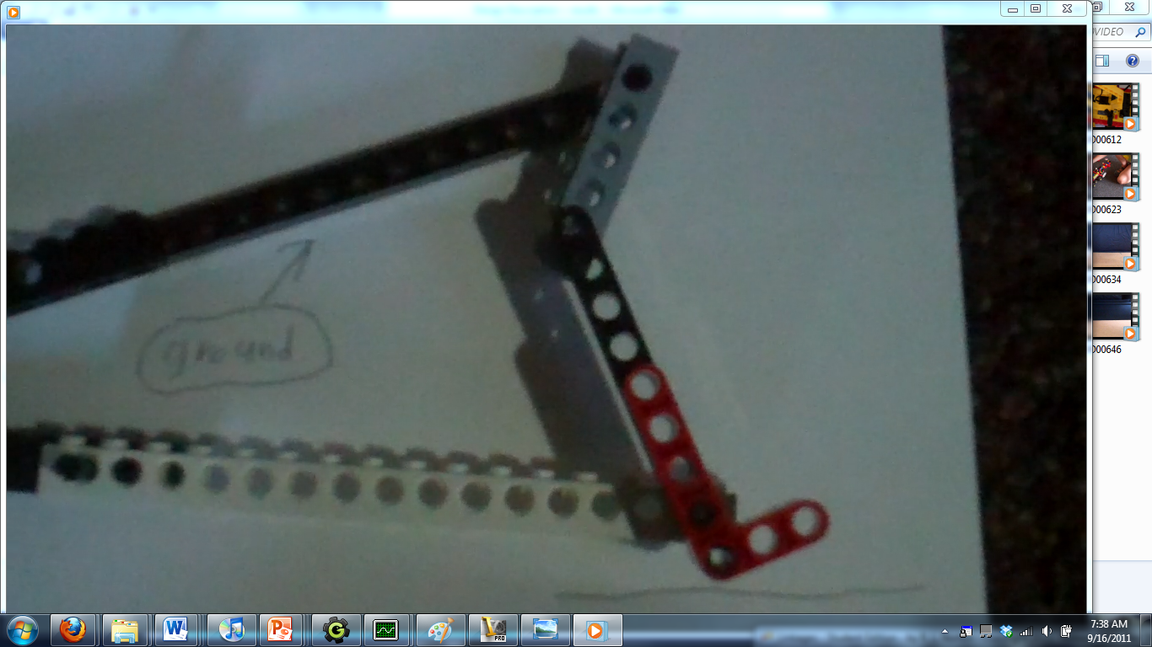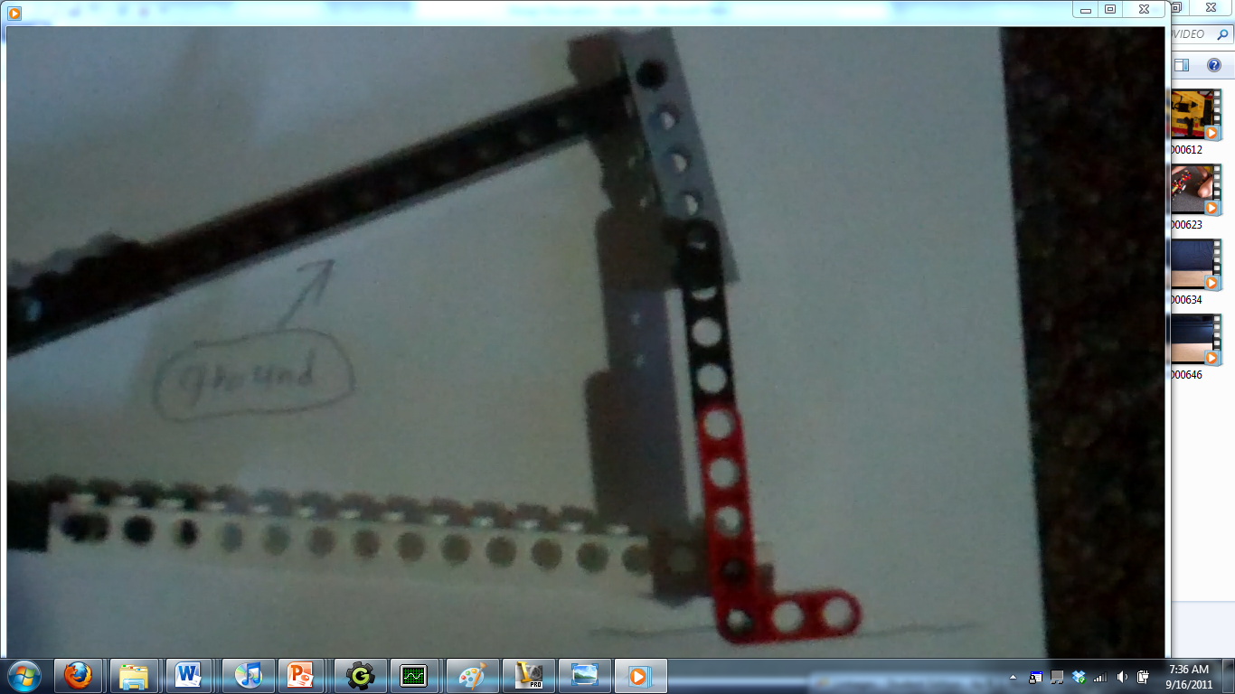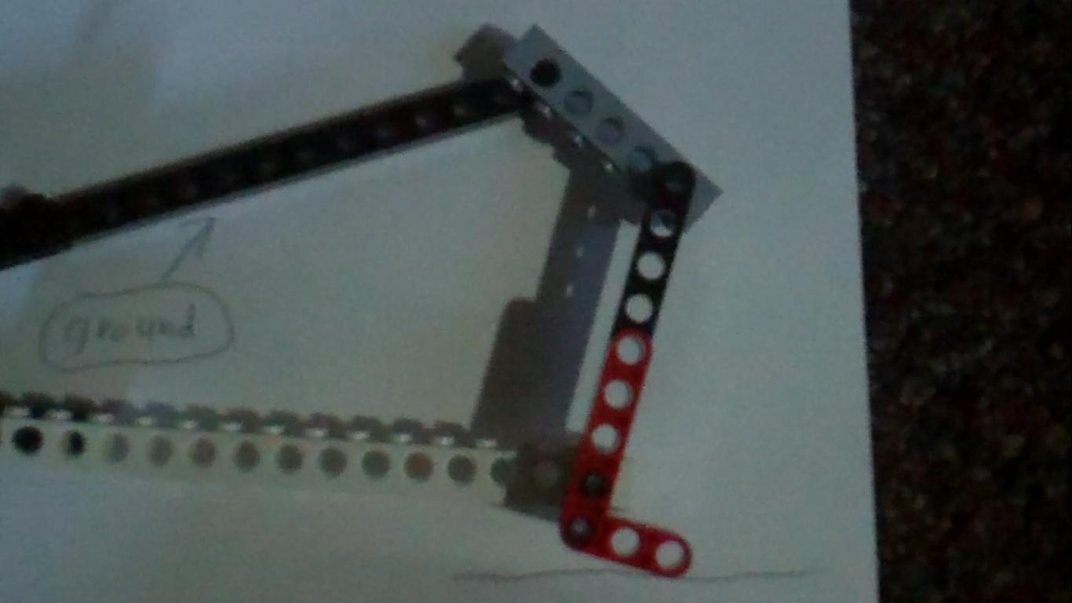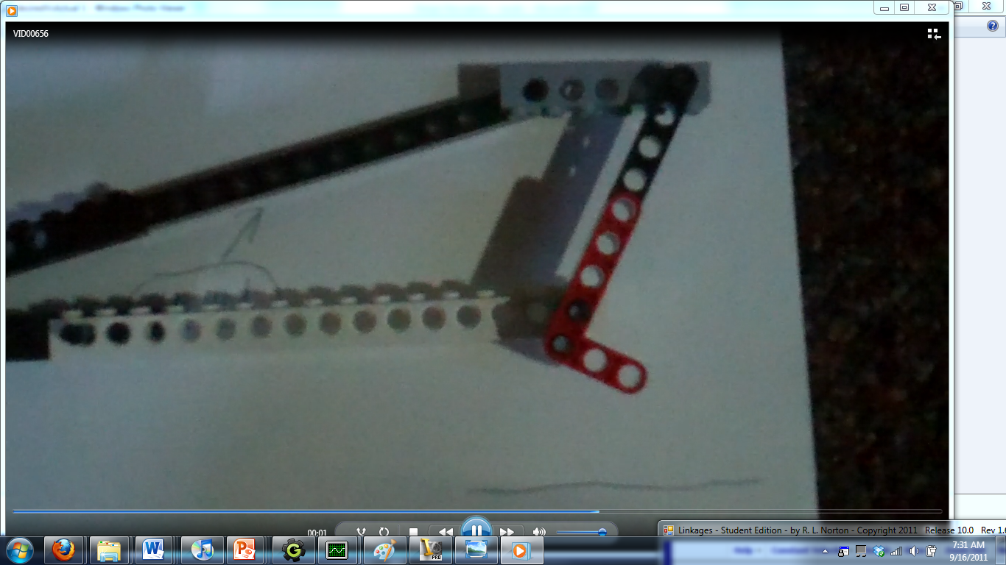

*Figure 5.4: The motions of the boot (red,) from the LEGO prototype of the long linkage*

The obvious problem with this linkage was its large size. This problem was remedied by replacing the long coupler link with something smaller. First, an offset peaucellier linkage was used to simulate the large arc of the coupler link, in a much smaller space. Later, we drastically simplified the design by approximating the curve as a straight line, and converting the design to a simple crank-slider.

But this simplification made a more subtle problem with this design obvious, illustrated by *Figure 5.6*. The system, when driven at constant speed, had an unacceptable duty cycle, not even 10% in the most generous designs. Tests were very accurate, but took up a tiny percent of the machine’s cycle time, wasting both time and power. Maximizing duty cycle was judged as one of our most important specifications, since the army wants the machine to operate through 100,000 cycles. 100,000 cycles with 90% of their time wasted is unacceptable. Theoretically, a quick return mechanism could have been incorporated to improve the duty cycle. But generating the quick return ratio required would involve a prohibitively large amount of input power.

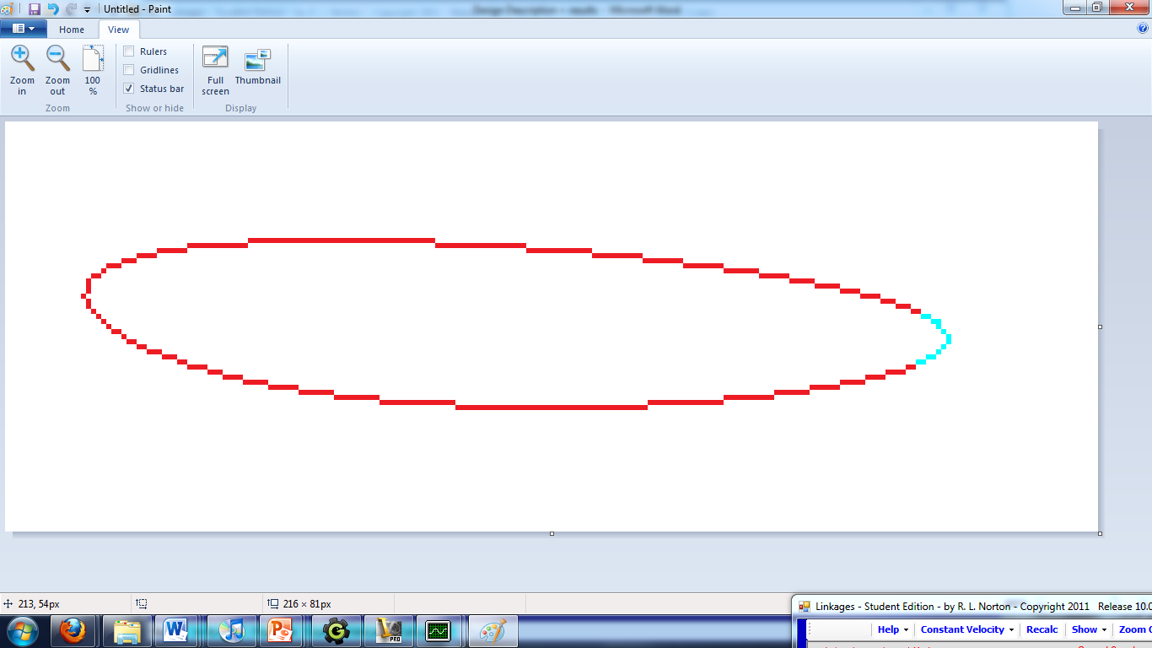

*Figure 5.6: The duty cycle (blue) and reset curve (red) of a crank-slider design*

**5.5 More Brainstorming**

While the crank-slider design did not meet our specifications, it did expose us to an out-of-the-box design, and the interesting results they can generate. This gave us a desire to search for more unusual concepts, we brainstormed more concepts, this time with much more awareness of the problem, and a focus on unorthodox designs. Many designs incorporated crank slider mechanisms, after seeing the ease with which they could raise and lower the boot. Designs were generally created with a great deal of emphasis on the angular position of the boot, as it was becoming clear that this was one of the hardest task specifications to meet.

Two of the most notable concepts from this brainstorming session would later be incorporated into our final design. The first one, termed the quick return rocker, used a rocking link pivoting near the sole of the boot as the boot’s connection point. This design incorporated a Crank-Shaper quick return mechanism, to maximize cycle time. However, as drawn, the concept featured no way to lift the boot off the load plate, and a fairly rough approximation of the coupler curve, treating it as a pure arc. Figure 5.7 shows a kinematic diagram of this linkage

KD of quick return  
 The other interesting system, termed the coupler driven slider, consisted of a standard grashof crank rocker. The coupler was converted to a ternary link, which drove a slider along the length of the rocker. The boot would have connected to the slider. In theory, the slider would have been pushed downwards as rocker rotated one way, and lifted as it returned, controlling the vertical position of the boot. In practice, the geometry proved problematic. Many configurations were modeled using Autodesk Inventor. A satisfactory coupler curve match was never achieved, partially because this system was difficult to simulate, since it could not be modeled in LINKAGES. Figure 5.8 shows a kinematic diagram.

KD of coupler driven slider

At this point, frustration with the process became apparent. New concepts were becoming increasingly complex and impractical. We kept on questioning if our task specifications were too harsh, and looking for quick and dirty solutions. Some of these included a linkage large enough to effectively consider the coupler curve to be an arc, a four bar linkage designed to accurately produce a cusp at the sacrifice of cycle time, and several systems that made excessive use of springs.

But at this point, we’d had several concepts that satisfied the majority of the specifications. All that was left was to find the perfect combination.

**5.6 The “Eureka!” Moment**

After a period of incubation following the second brainstorming session, a solution that matched all task specification was suddenly discovered. The key concept behind this concept was the separation of position and angle into two mechanisms, one of which drives the other. Previously, we had developed systems that controlled the X and Y position quite well, while coming up short on angular position, and other systems that moved the boot to precision angles, but with unsatisfactory X and Y position. All that was needed was to combine them.

For X/Y position control, we used our most accurate mechanism in that area, the four bar linkages derived from the symmetrical four bar. The design of this mechanism is shown in figure 5.9; it consists of a ground link (1), driven crank (2), triangular coupler (3), and rocker (4).

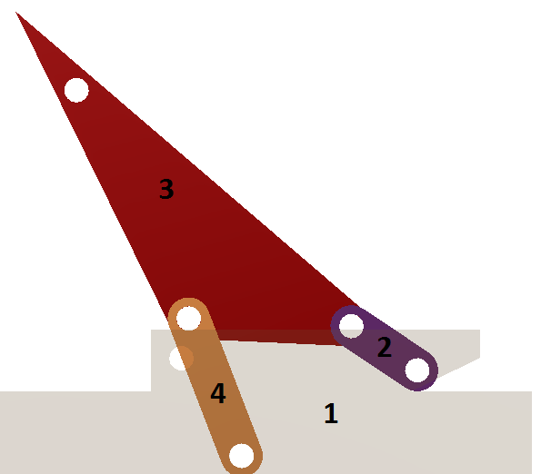 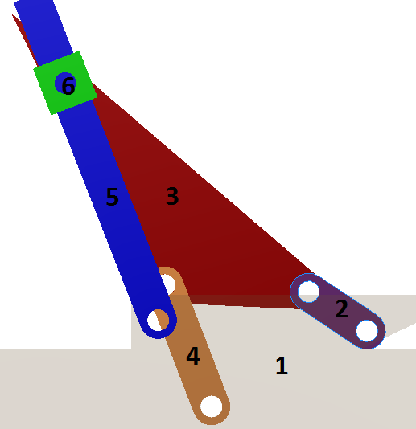

*Figure 5.9: The four bar driving linkage (left,) and the complete 6 bar linkage (right.) Kinematic diagram included in appendix*

For angular control, we used a second rocker (5), precisely placed such that its two extreme angles match the specified boot angles. These two mechanisms were connected using a slider (6), which pivots at the coupler point. The slider will move with the coupler point, and push on the second rocker. The slider will drive the rocker through angular motion, while remaining free to slide up and down the rocker, to mask discrepancies between the second rocker’s circular motion and the slider’s motion along the coupler curve. Any motion of the slider in the Y direction of the second rocker’s local rotating coordinate system has no effect on the second rocker’s angular position.

Putting it all together, the coupler curve forms a short and wide shape, with clear maximum and minimum X positions. Intersecting lines were drawn between the maximum, minimum, and approximate cusp (0̊ boot angle) positions of the coupler curve. As illustrated in *figure 5.10*, specifying angles between these lines of 22 and 41 degrees sets their intersection point as the pivot point for the cocker.

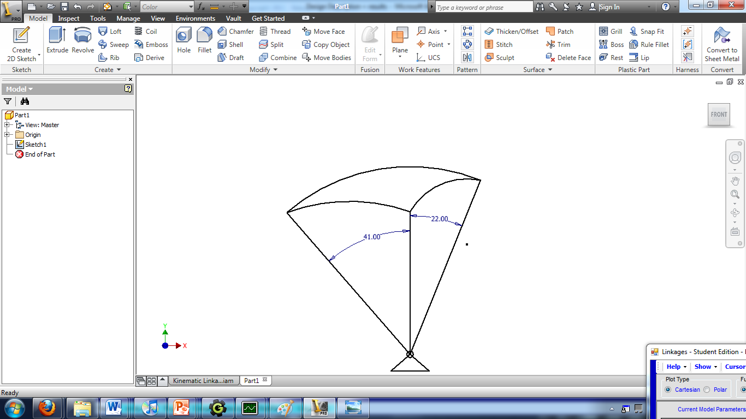

*Figure 5.10: Graphically determining the pivot point of the second rocker*

For terminology, this device could be considered a form of Stephenson’s six bar linkage. It consists of two ternary links, the grounded link, and the coupler. There is no direct connection between the ternary links. The ternaries are connected in three places, twice by single links (the crank and rocker,) and once by two links (the slider and second rocker). Throughout the rest of the project, this device was termed a Stephenson slider-rocker.

One key advantage of this design is that it could be tested in parts. As will be discussed in section 5.7, the geometry of the four bar portion was developed and perfected first. Only once this work was complete was the geometry of the slider-rocker considered.

**5.7 Tweaking the Four Bar System**

To get a better understanding of the quality of this design when compared to others, we created a table that resembles a design selection matrix. *Table 5.1* lists several designs, and several task specifications that have proven critical, yet difficult to reach throughout the process. In order to be feasible, a design should score at least acceptably (5 or greater) on each of these.

**Table 5.1: Critical Task Specifications**

|  |  |  |  |  |  |
| --- | --- | --- | --- | --- | --- |
|  | **Duty Cycle** | **Angular Accuracy** | **Positional Accuracy** | **Test/Reset?** | **Transmission Angle** |
| Crank-slider | 1 | 8 | 8 | 10 | 10 |
| Pure four bar | 7 | 2 | 10 | 10 | 4 |
| Chebyschev and driver dyad | 5 | 8 | 6 | 1 | 8 |
| Stephenson slider rocker | 7 | 10 | 10 | 10 | 4 |

As shown, the Stephenson slider rocker scored better than other potential solutions across the board, except on transmission angle. Transmission angles were a cause of problems on the original pure four bar designs, although they were overshadowed by the lack of angular position control. But now that angular position doesn’t need to be considered in the design of the four bar linkage, transmission angles can be improved.

To improve transmission angles, a mathematical approach was used. The minimum transmission angle of an open Grashof crank-rocker linkage is found by the formula $\cos^{-1}({\frac{ {coupler}^{2}+{rocker}^{2}-{(ground+crank)}^{2}}{2ab}}$). Therefore, to improve transmission angle, the ground or crank length may be reduced, or the coupler or rocker lengths may be increased. This process created several four bar designs with coupler curves similar to *figure 5.11*. These designs provided a relatively gentle curve, featuring a nearly flat side, and a longer curved side. This gentler motion was partially the result of gentler transmission angles, generally approximately 45̊ . Other similar designs had been rejected earlier, because they did not provide enough rotation at the coupler point. But with the Stephenson slider rocker system, coupler point rotation doesn’t matter.

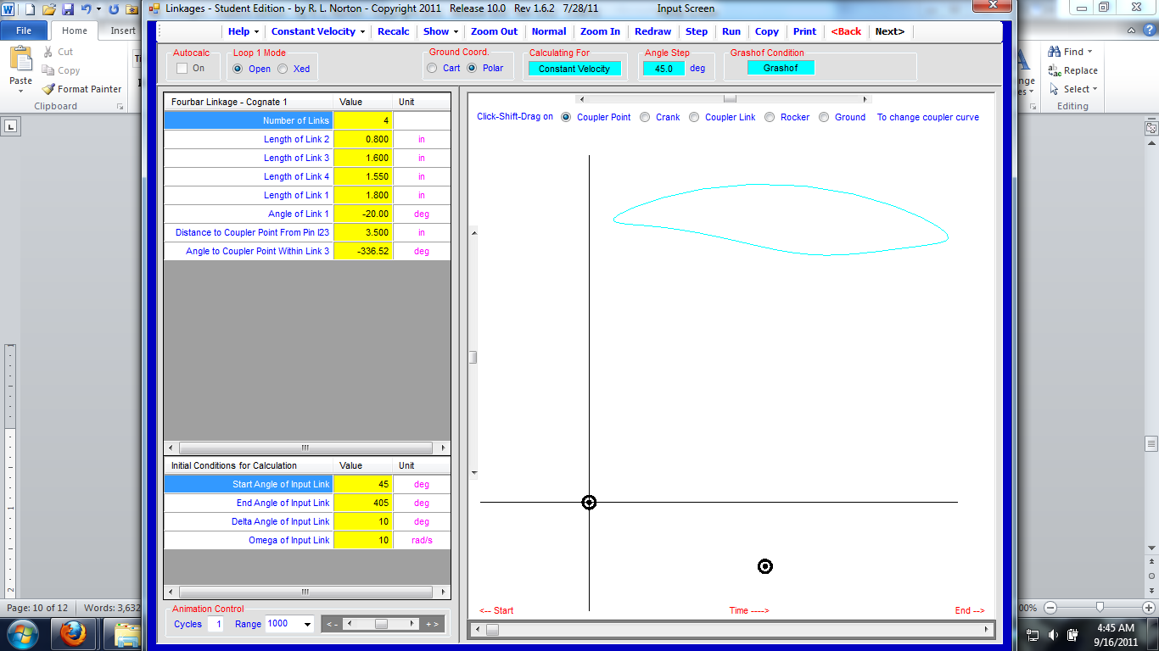

*Figure 5.11: The Flat/round curve which produced more favorable transmission angles*

As was mentioned in section 5.2, some point on the boot, generally those off-center, matched this flat/round curve. Once this general match was identified, creating the best fit was a simple matter of minor tweaking. A CAD representation of the boot’s curve was used, allowing the geometry to be dynamically updated to match the coupler curve. Five different coupler curves of the same basic form, with tiny geometric tweaks were used to attempt to find a match. Eventually, a match was found, which deviated from the idealized boot curve by less than half an inch. The actual curve is shown in blue in figure *5.12*, along with the ideal curve in black. The precise geometry of the four bar linkage that creates this curve is in the appendix.

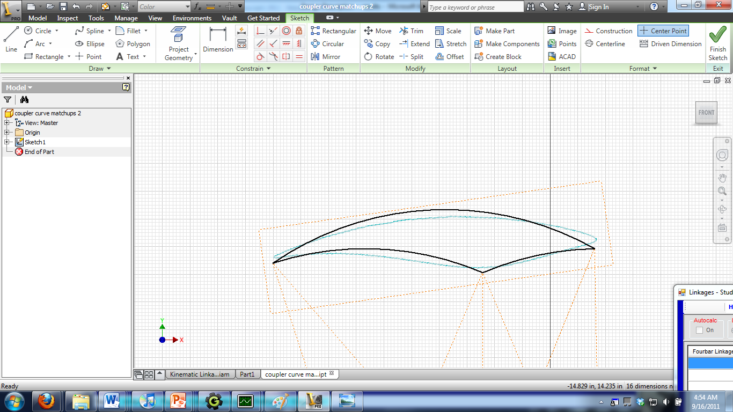

*Figure 5.12: Idealized (black) and actual (blue) coupler curves*

From there, final design work on the linkage was simple. The linkage was scaled, by measuring the tip-to-tip distance of the idealized and actual curves. A scaling factor was generated by dividing idealized by actual. Each link length was then multiplied by this scaling factor, to convert from the arbitrary scale the coupler curve was developed using, to the real scale of the linkage. After the four bar curve was scaled, the slider rocker assembly was dimensioned, using the procedures outlined earlier.

**Results**

**6.1 Description of Final Design**

Our final design took on the form of the Stephenson slider rocker described in section 5.6. A crank-rocker four bar is used to drive the ternary coupler link. The third point of the link is pinned to a slider, which moves along a second pivoting rocker. The slider takes on the X and Y position of the coupler point, and the angular position of the second rocker.

The final design effectively followed the motion of a point relatively near the boot, which resulted in an extremely compact linkage. As shown in *figure 6.1*, the link lengths in the four bar ranged from 2.8 to 12.4 inches. Even the second rocker was only 14 inches long. This resulted in a final planar volume of just over 18” * 18”, well within the task specification of 4’ * 4’.

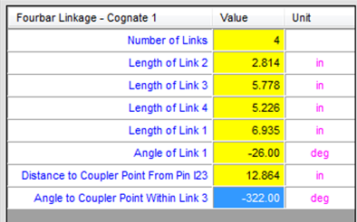

*Figure 6.1: Dimensions of the final four bar linkage.*

**6.2 Initial Motion Tests**

Initial testing was conducted using prototypes and computer models, to verify that the linkage’s geometry was correct, and that the boot travelled as desired. The linkage was drawn using the CAD package Autodesk Inventor, from the dimensions in Figure 6.1. The boot was placed relative to the coupler point using the dimensions in *figure 6.2*, in order to best match the coupler curve used.

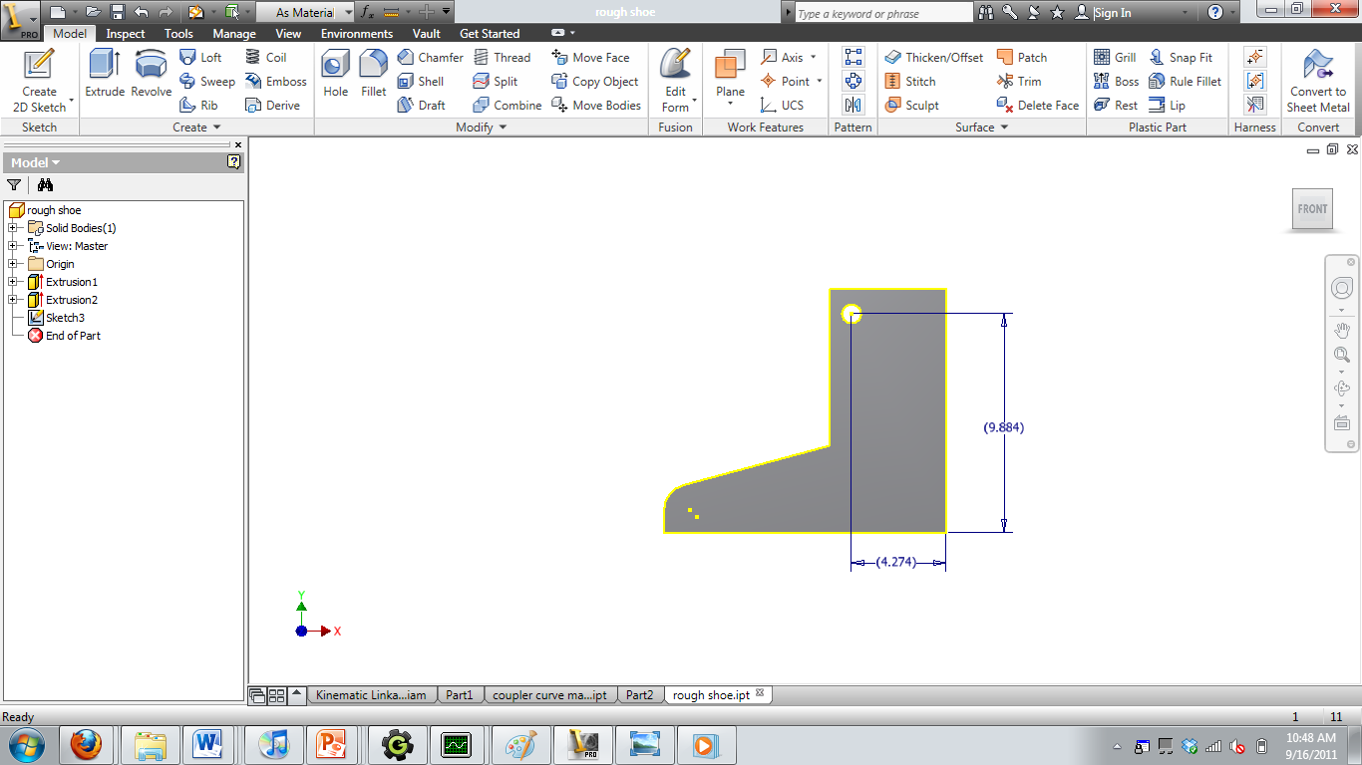

*Figure 6.2: Dimensions of the shoe’s attachment point to the slider, relative to the tip of the heel. The test shoe is 12.75” long overall.*

A horizontal ground plane was placed flush with the base of the boot in the level position, approximately ¾” beneath the crank’s pivot. The boot rests flush with this surface. As the boot reaches heel down and toe down positions, the rigid model of the boot was expected to sink into this ground plane, to simulate bending forces on the boot. This sink should be small for the heel down position, and fairly significant with the toe down.

Testing was a success, as demonstrated by figure 6.3. The boot rocked across the ground plane, with negligible sliding in the X direction. The boot sunk into the plane slightly at the heel (1), and significantly around the toe (3). Angle control by the slider rocker was spot on. And during the return stroke, the boot did not contact the load plate (4). The effect of the quick return was also evident, when the linkage was animated.

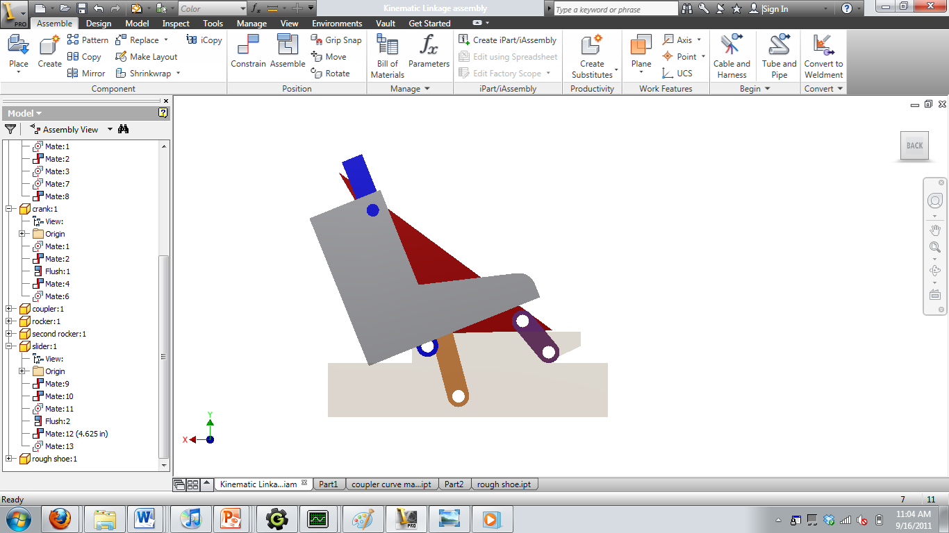 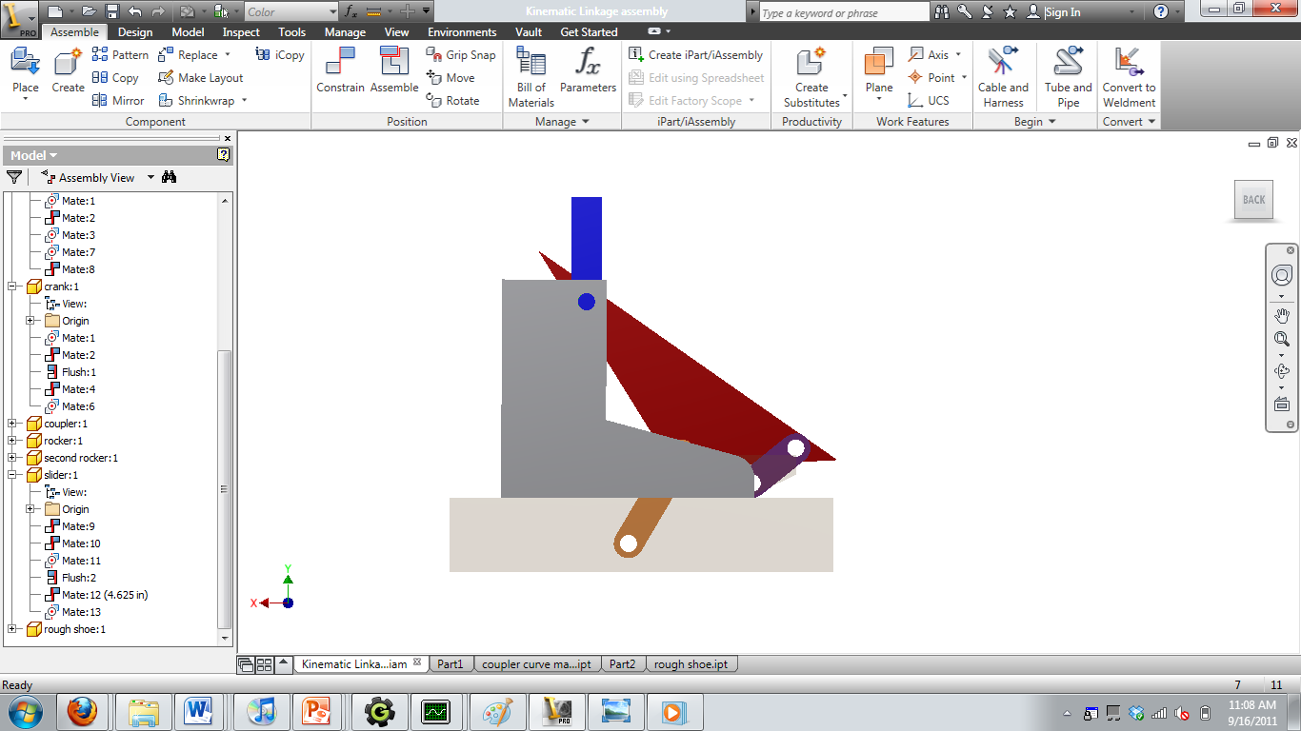 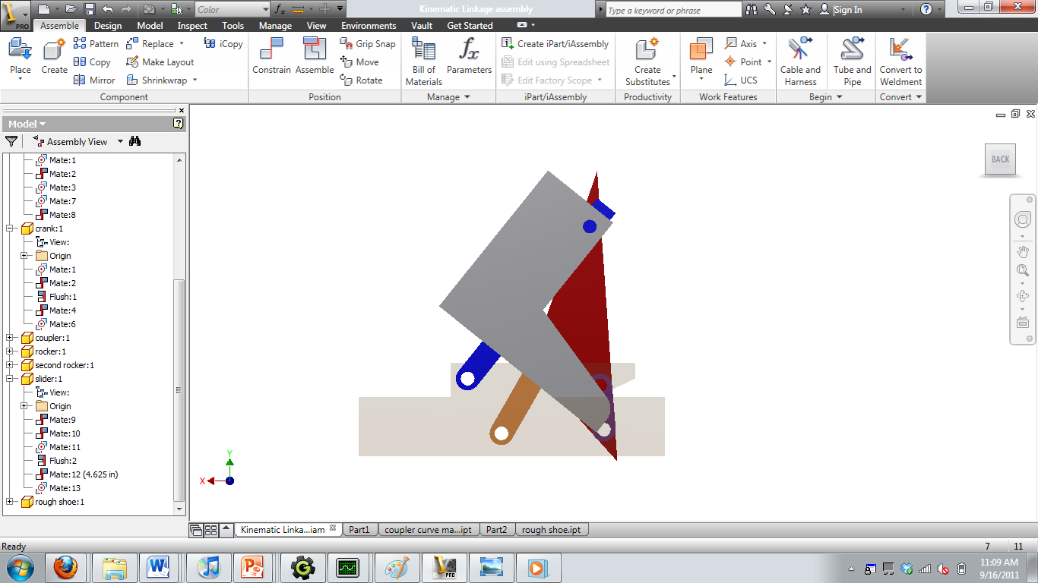 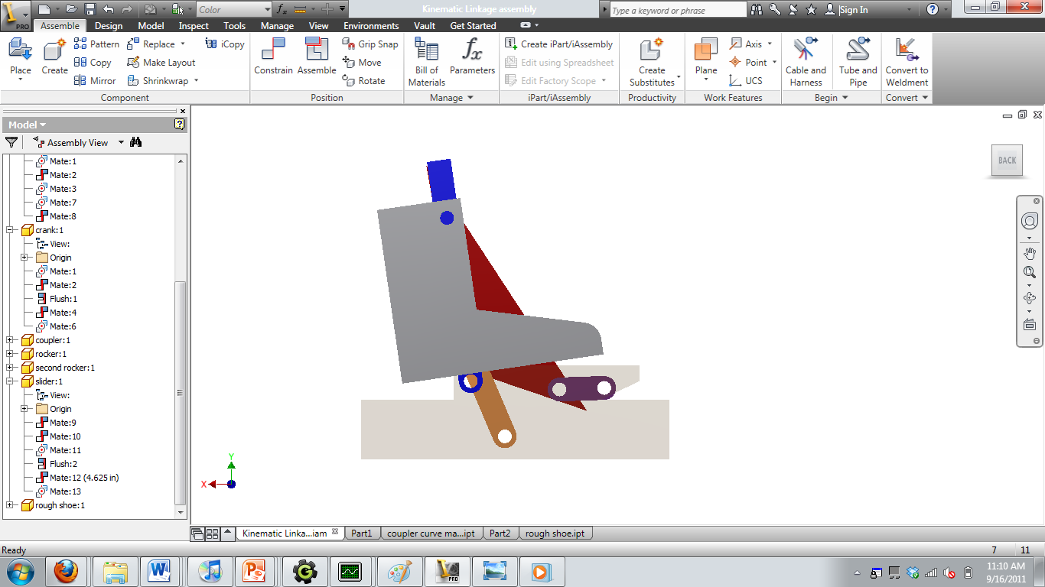

(4)

(3)

(2)

(1)

*Figure 6.3: From left to right: The heel down, flat, toe down, and return positions of our mechanism.*

**6.3 Basic Analysis**

After the visual confirmation that our linkage was moving as desired, we moved onto mathematical analysis of the linkage. First up was the degree of freedom. The linkage features 6 links, and 7 full joints (6 pins and 1 slider). Feeding these numbers to Gruebler’s equation, the degree of freedom is equal to 3(6-1) – 2(7), or simply one degree of freedom. This is reflected in the linkage’s behavior. The angular position of the crank is the only parameter needed to control the position and angle of every other link.

After the degrees of freedom were verified, the next test was of Grashof condition. The Grashof condition does not directly apply to six bar linkages. But our design features a four bar sub chain, which required a continuously rotating input link in order to operate correctly. This four bar sub chain needed to meet the Grashof condition, of S+L < P+Q. Calculation of the Grashof condition was done as follows:

S=crank=2.814”

L=ground=6.935”

P=Coupler=5.778”

Q=Rocker=5.226”

S+L=9.749”

P+Q=11.004”

S+L < P+Q, Grashof

S=input, Grashof crank-rocker-rocker

After the Grashof condition was verified, transmission angles were calculated. For the four bar linkage sub chain, a transmission angle of at least 35 degrees was required. Maximum and minimum transmission angles are found as the crank aligns with the ground link, and can be found using the law of cosines. The math done to find the transmission angles can be found in the appendix. The result was a minimum transmission angle of 43.6̊, well beyond the minimum set by the task specifications.

Following the transmission angles, we calculated the linkages duty cycle. In other words, we wanted to know what percent of a revolution of the crank was used for testing, and what percentage was spent on resetting the mechanism. This information was derived from a graph of X velocity, created by LINKAGES, and shown in *figure 6.4*. When the X velocity is negative, or to the left, the boot is being tested. When X is positive, the system is being reset. The graph produced zeroes at 43 degrees and 272 degrees, and was negative in between these values. 272-43 is 229 degrees, or 64% of a full circle. Therefore, our linkage has a duty cycle of 64%, above the minimum value of 50%.

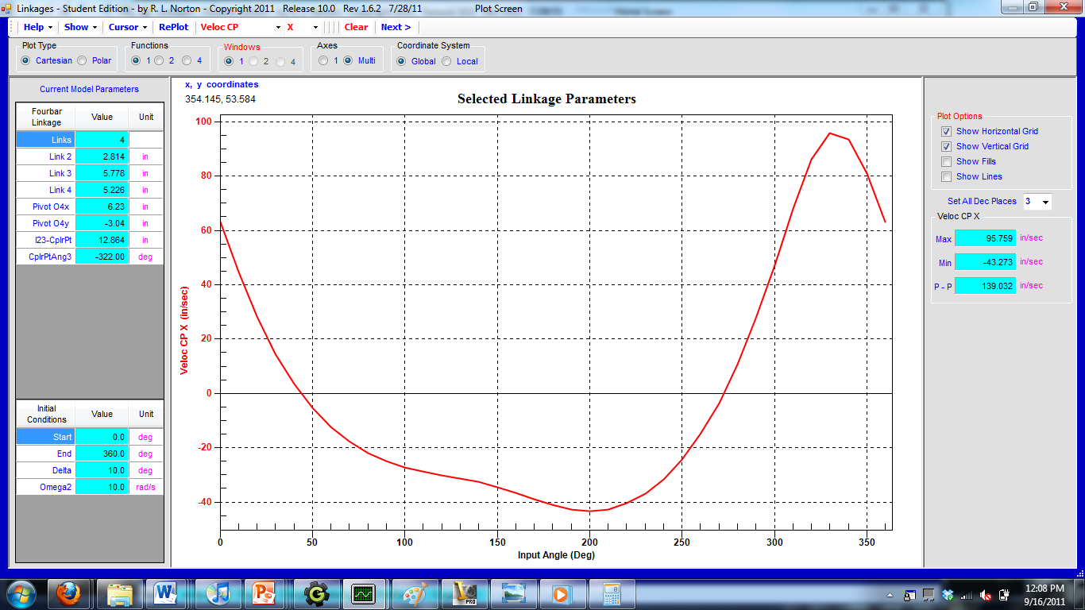

*Figure 6.4: The X velocity of the coupler point with respect to the input angle. Zeroes occur at 43̊ and 272̊.*

Mechanical advantage of our design was also calculated, between the crank input and the rocker. The rout distance was assumed to be the length of the rocker, since the rocker transfers force to the rest of the mechanism at this point. Mechanical advantage was calculated at three points: the heel down position (θ2 = 43̊), the flat position (θ2 = 140̊), and the toe down position (θ2 = 256.94̊). To make the calculations using the formula Ma=($\frac{O_{4}B\sin{u}}{O_{2}A\sin{v}}$)($\frac{r_{in}}{r_{out}}$), the values of u (transmission angle) and v were calculated at each of these three crank angles. u was calculated to move from 73̊ to 56̊ to 77̊. V moved from 0̊ to 36.4̊ to 31.97̊. Using these values, and a constant rin of 2.8” and an rout of 5.226, the mechanical advantage was calculated to be infinite at the heel up position (as expected, since the coupler and crank lie inline with each other), 1.397 at the flat position, and 1.84 at the toe up position.

**6.4 Other Practical Considerations**

If this system were to be built in real life, a number of practical limitations would come into play. Two versions of the mechanism would likely be used, placed on either side of the boot. The links would likely take on more complex geometries, in order to best handle the loads generated by the device. A drive motor and related mechanisms must be connected to the crank.

Little was specified about the geometry of the load plate in the problem statement. Since this is being provided to us, the behavior and geometry of the load plate would be a key driving constraint, if the system were to be realized.

The connection between the crank and the slider would need a slight amount of spring loading, to correct small anomalies in the coupler curve used. These deviations were kept to a minimum, under ½”, by our design. But springs will still create a more realistic boot motion, and eliminate any translation along the load plate. Spring loading comes at the expense of increased driving torque.

**7: Conclusion:**

In the end, a four-bar linkage that simulated the foot’s motion of an army soldier’s marching was successfully designed. In addition to the four linkages, a slider was included into the mechanism in order to create the angles necessary to mimic the desired marching movement. This slider proved to be very useful since it allowed the foot to move as required. Also, after the mechanism was developed, the importance of documenting everything was remarked since the final solution was heavily based on early, instant-reject designs. Also, clear focus on the problem was crucial in determining the ultimate design of the mechanism.

**8: Bibliography:**

1. *Analysis of Walking Angles*. Dir. Joe D. Gallagher. Perf. Joe Gallagher, Jack Gallagher, Paul Gallagher, Jeanne Gallagher. 2011.
2. *Army Cadence Master - YouTube*. *YouTube - Broadcast Yourself.* 30 Oct. 2006. Web. 4 Sept. 2011. <http://www.youtube.com/watch?v=_oV5Z2bOVAI>.
3. *BBC - BBC One Programmes - Wallace & Gromit's World of Invention, Nature Knows Best*. Prod. Rob Baker. Dir. Merlin Crossingham. *BBC - Homepage*. Web. 5 Sept. 2011. <http://www.bbc.co.uk/programmes/b00vt1xp>.
4. *Boot Testing Machine. Perf. Brian Siwinsky. Robert L. Norton. Web. 5 Sept. 2011*
5. Hrones, John A., and George L. Nelson. *Analysis of the Four-Bar Linkage: Its Application to the Synthesis of Mechanisms*. New York: Technology of The Massachusetts Institute of Technology and John Wiley & Sons, 1951. Print.
6. "JANSEN - KLANN LINKAGE COMPARISON." *MECHANICAL SPIDER*. 2008. Web. 15 Sept. 2011. <http://www.mechanicalspider.com/comparison.html>.
7. Jansen, Theo. *Theo's Jansen Strandbeest*. Digital image. Web. 10 Sept. 2011. <http://www.strandbeest.com/beests_leg.php>.
8. Jared. *San Francisco - Exploratorium - Shoe Tester*. Digital image. Web. 14 Sept. 2011. <http://www.flickr.com/photos/jared422/4183940714/>.
9. Klann, Joseph C. Walking Device. Patent US006478314B1. 12 Nov. 2002. Print.
10. Klann, Joseph. *Positions*. Digital image. 2005. Web. 10 Sept. 2011.
11. *MIT 2.75 Engineering Medical Devices: Design and Testing of a 3-axis Machine Used to Characterize the Performance of Running Shoes*. *CIMIT*. 17 Feb. 2009. Web. 5 Sept. 2011. <http://www.cimit.org/forum/forum-new-02.17.09.abshire.html>.
12. MTS Systems Corporation. *The 858 Mini Bionix® II Test System*. 1999. PDF.
13. Norton, Robert L. *Design of Machinery: an Introduction to the Synthesis and Analysis of Mechanisms and Machines*. 5th ed. New York, NY: McGraw-Hill, 2011. Print.
14. "Theo Jansen Mechanism." *Mechanism Flash Animations*. Web. 6 Sept. 2011. <http://www.mekanizmalar.com/theo_jansen.html>.
15. Trimble, Tyghe. "Barefoot Running Shoes - Running Barefoot Debate - Popular Mechanics." *Automotive Care, Home Improvement, Tools, DIY Tips - Popular Mechanics*. Web. 11 Sept. 2011. <http://www.popularmechanics.com/outdoors/sports/technology/4314401>.
16. *Walk Reference Video - YouTube*. Dir. Yash Gupta. Perf. Yash Gupta. *YouTube - Broadcast Yourself.* 27 July 2010. Web. 4 Sept. 2011. <http://www.youtube.com/watch?v=WBp6lfPy5wU>.

**Appendices**

**Calculation of maximum and minimum transmission angles**

Transmission angles:

Ground-crank=6.935-2.814 =4.121, “c”

Coupler, 5.778”, “b”

Rocker, 5.226”, “a”

c2 = a2 + b2 – 2abCos(C)

$C= \cos^{-1}({\frac{ a^{2}+b^{2}-c^{2}}{2ab}}$)

C = $\cos^{-1}({\frac{ {5.778}^{2}+{5.226}^{2}-{4.121}^{2}}{2(5.778)(5.226)}}$)

C = 43.62̊

Ground-crank=6.935+2.814 =9.749, “c”

Coupler, 5.778”, “b”

Rocker, 5.226”, “a”

c2 = a2 + b2 – 2abCos(C)

$C= \cos^{-1}({\frac{ a^{2}+b^{2}-c^{2}}{2ab}}$)

C = $\cos^{-1}({\frac{ {5.778}^{2}+{5.226}^{2}-{9.749}^{2}}{2(5.778)(5.226)}}$)

C = 124.66

43.62= minimum transmission angle

**Data from Video Analysis**

|  |  |
| --- | --- |
| **Heel Angle** | **Toe Angle** |
| **22** | **35** |
| **25** | **44** |
| **20** | **38** |
| **21** | **40** |
| **23** | **40** |
| **25** | **43** |
| **18** | **45** |
| **22** | **41** |

Averages: Heel, 22̊, Toe, 41̊.

**Kinematic Diagram of Final Design**